Farmers ZSOA
Zurich Services Oriented Architecture

FNOL – WC Provider Information Management Service
Technical Design

Version 1.0



Farmers Service Competency Center

Copyright Zurich Financial Services

Document History

Version | Date | Author | Comment
1.0 | 06/25/2008 | Emmanuel Ameh | Initial Draft

Table of Contents
1 About this Document 5
1.1 Introduction 5
1.2 Intended Audience 5
1.3 How this document is organized 5
1.4 Reference Architecture 5
1.5 Service Overview 7
Orchestration Layer Components 9
1.6 ESB Components 9
1.6.1 ALSB 9
1.7 Client interface 10
1.8 Message flow 11
1.9 Transformations 11
1.10 Routing 11
2 Service Enablement Layer Components 12
2.1 Interface 12
2.1.1 Functionality Required 12
2.1.2 Inputs 12
2.1.3 Outputs 12
2.1.4 Faults 13
2.1.5 Data Modifications 13
2.1.6 Logical Flowchart 13
3 Implementation Layer Components 14
3.1 Class Diagram 14
3.2 Mainframe Programs 15
3.2.1 Program Name 15
3.2.2 Region 15
3.2.3 Linkage section 15
3.2.4 Procedure Division declaration 15
3.3 EJB’s 15
3.4 Database\Stored Procedures 15
4 Functional\Non-functional requirements 16
4.1 Functional 16
4.1.1 Feature specifications 16
4.2 Non-functional 16
4.2.1 Security 16
4.2.2 Logging 16
Logging is provided by Amber-point 16
4.2.3 Monitoring 16
4.2.4 Business exception handling 16
4.2.5 Response time 16
4.2.6 Concurrent Users 16
4.2.7 Throughput Requirements 16
4.2.8 Availability 16
5 Business Contacts 17

About this Document

Introduction
This document describes the design artifacts and implementation model of the Provider Information Management Service. Although external systems (upstream and downstream) are referenced in this document, their detailed behavior falls outside the scope of this document. Overall system requirements are covered in the requirements and use case document and, therefore, also fall outside the scope of this document.

Intended Audience
This document is intended for the team members who will be responsible for development of this service.

How this document is organized
The design for the Provider Information Management Service is presented in 4 areas of interest as outlined below.
- Orchestration Layer Components: Presents the services, components and information pertinent to this level. The primary focus here is on the Enterprise Service Bus and the activities carried out there.
- Service Enablement Layer Components: Describes the design and pertinent aspects needed to develop the atomic services as well as any other aspects implemented at this level.
- Implementation Layer Components: This deals primarily with backend or legacy data sources and the design to follow in exposing their services to the enterprise.
- Functional\Non-functional Requirements: This section outlines the functional and non-functional requirements identified for this service.

Reference Architecture
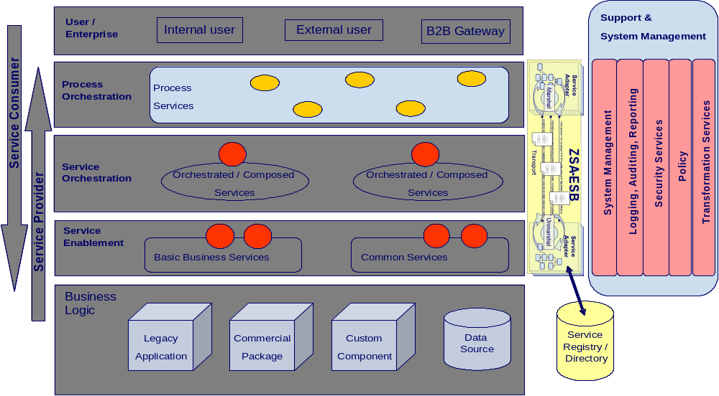

Fig 1.1
As shown in the above diagram, the Provider Information Management Service will follow the reference architecture defined in the “ZSA_Tech_Ref_Architecture” document.
No special implementation is required for security and transformation for providing web services to the (Consumer). The detail of the implementation is explained below:
The end-to-end flow for the provider NWCS will follow the steps shown in the diagram 1.2:

FNOL - WC

O R
LOAD BALANCER
Data Power
(Data Transformation)
NWCS
(PROVIDER)

ALSB
retrieveContactPointDetailsForProvider( )

ZSOA
FARMERS
IAA Request (INTERNAL)

O R

Diagram 1.2

As shown in diagram 1.2, FNOL-WC consumer sends a set of input data as string and gets a response which contains: Vendor Type, Contact Type, Vendor Name, Address, City, State, Zip, Phone, Fax, First Name, Last Name and Entity Type at the location of the provider.
Here Provider Information Management Service component returns provider location and contact information (includes address and organization) of the location in the response messages.

Service Overview
This service will return the provider information and location depending on the data elements provided by the service consumer in the request message.
As per the reference architecture, Party Object has implementation components in the Service Enablement, Atomic, and Orchestrated layers.

.

Anticipated URLs for Provider. URLs will be provided after the iNET application has been service enabled.

Orchestration Layer Components

ESB Components

ALSB

1.6.1.1 Business Service
This section contains the details necessary to define the business service in the ESB.

General Configuration
Service Name | Provider Information Management Business Service
Description | The purpose of Provider Information Management Service is to retrieve the list of providers and the provider’s location information, for a given set of input data elements from the service provider NWCS.
Service Type | Web service
Transport Configuration
Protocol | HTTP
Load balancing | No
Endpoint URI | http://services.farmersinsurance.com/services/<<tbd>>
Retry count | 0
Retry interval | 0 seconds
HTTP Transport Configuration
Timeout | Default to server
HTTP Request Method | Post
Authentication | No
Follow HTTP redirects | No
SOAP Binding Configuration
Enforce WS-I Compliance | Yes

1.6.1.2 Proxy Service
This section contains the detail necessary to define the proxy service in the ESB.

General Configuration
Service Name | ProviderInformationManagementProxyService
Description | This service fronts the primary business service
Service Type | WSDL Web Service
Proxy Service Provider | N/A
Protocol | HTTP
Endpoint URI | http://services.farmersinsurance.com/services/<<tbd>>_proxyService
Get All Headers | No
Headers | N/A
HTTP Transport Configuration
Authentication | No
Message Level Security Configuration
Custom Authentication | No
Operation Selection Configuration
Enforce WS-I Compliance | Yes
Selection Algorithm | SOAP Body Type

1.6.2 WSDL
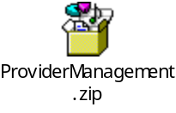

Client interface
A consumer will access this service via a WS-I v1.1-compliant web service invocation. This service uses the wrapped document literal binding style. The request/response messages are in IAA canonical format and the consumer has the responsibility to map the XML message structure to their internal format.

Message flow
Message Flows are the definitions of AquaLogic Service Bus proxy services. Pipelines (Request and Response pipelines), branch nodes, and route nodes define the implementation of AquaLogic Service Bus proxy services. There will be a Pipeline Pair required to handle the request and response, and Route node required and there is no requirement for branch nodes. ALSB which provides a route node is used to perform request/response communication between Proxy service and Provider Information Management Service. The route node supports conditional routing as well as request and response transformations.

Transformations
Data transformation is the mapping of data from one format to another. DataPower transforms messages from IAA format to the service provider’s format. It uses the Xquery, XSLT transformation and XPath language for data composition and transformation for service endpoints. Data power supports data mapping that uses XQuery and the eXtensible Stylesheet Language Transformation (XSLT) standards. There is only one transformation component at the Data Power for transforming IAA service request (IAA message) to Provider Information Management service request. There is no data transformation since provider identifies SOAP/HTTP messages.

Routing
There is no need for routing as there is only one provider for the consumer of this service. In order to route the consumer requests to different providers, we follow content based routing.

Service Enablement Layer Components

Interface
The Provider Information Management Service is to be the result of building a service layer to interact with new third party providers who are classified as either contacts or vendors.

Functionality Required
A new service is to be enabled under Party Package in IAA. The WSDL files to be implemented for this service are located in section 1.6.2. Service enabling this new calling program will require mapping of the ZIAA canonical model to the existing inputs and outputs. The following table shows the native input\output elements to ZIAA WSDL mappings.
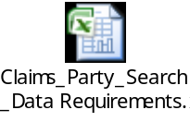

Inputs

Use Case Parameter | Type | Element | Schema
Vendor Name | String
First Name | String
Last Name | String
Work Address | String
City | String
State | String
ZIP Code | String
Contact Phone Number | String
Contact Type | String
Vendor Type | String

Outputs


Use Case Parameter | Type | Element | Schema
Vendor Type | String | vendorType | Party.xsd
Vendor Name | String | vendorName | Party.xsd
Address | String | address | Party.xsd
City | String | city | Party.xsd
State | String | state | Party.xsd
Zip | String | zip | Party.xsd
Phone | String | phone | Party.xsd
Phone Fax | String | phoneFax | Party.xsd
Last Name | String | lastName | Party.xsd
First Name | String | firstName | Party.xsd
Middle Name | String | middleName | Party.xsd
Email | String | mail | Party.xsd
Contact Type | String | contactType | Party.xsd
Entity Type | String | entityType | Party.xsd

Faults

U.C. Parameter | Element | Type | Schema
Technical Error | errorMessageType | String | (ZSOA.xsd)
Business Error | errorState | String | (ZSOA.xsd)

Data Modifications
Identify any data modifications which need to occur in the service enablement layer.
Field Name | Modifications
None

2.1.6

Logical Flowchart
Begin
ZIP
Call Provider Info Management Service to display search results
NWCS processes the request
processes the request
End
Yes
Success/failure

Create Error Message
Failure
Send response through ALSB to FNOL-WC,
Success

Implementation Layer Components

Class Diagram

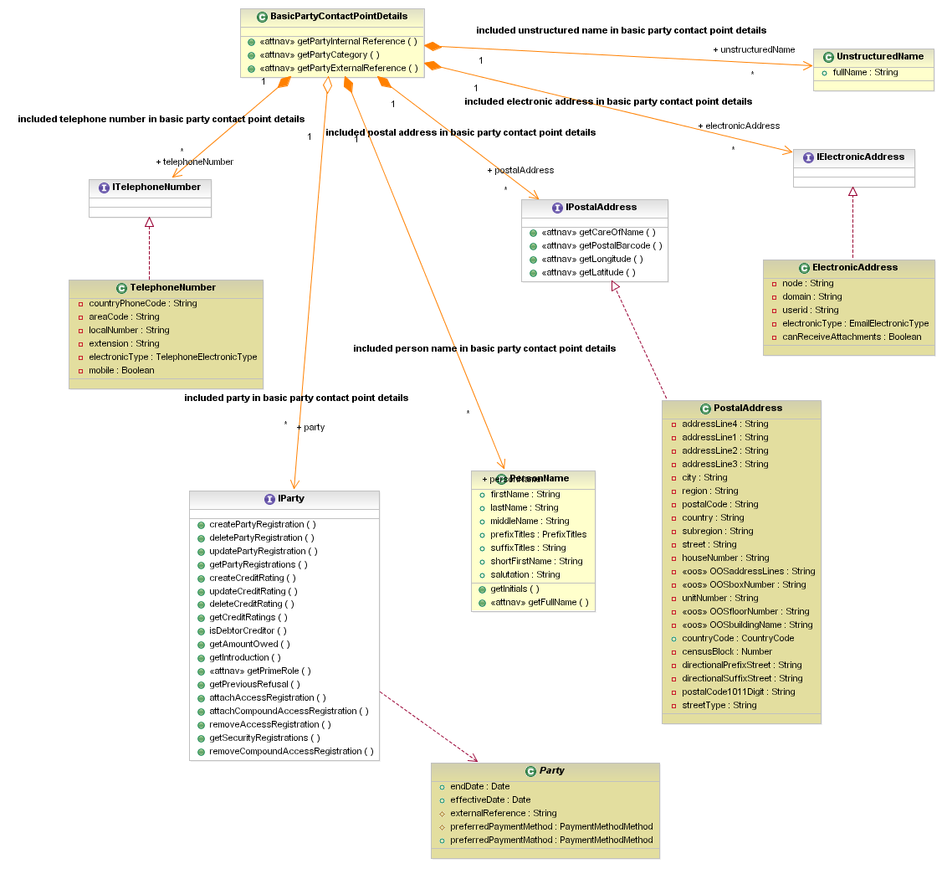

Mainframe Programs
<<None>>

Program Name
<<None>>

Region
<<None>>

Linkage section
<<None>>

Procedure Division declaration
<<None>>

EJB’s
<<None>>

Database\Stored Procedures
<<None>>

Functional\Non-functional requirements

Functional

Feature specifications
No special features are assigned to the functional requirements

Non-functional

Security
Since the provider is a public network, there is no message level and transport level security needed for this service. However, the service should be accessible within the Farmers’ domain.

Logging

Logging is provided by Amber-point.

Monitoring
Monitoring is provided by Amber-point.

Business exception handling
Return data error message when a wrong zip code is entered for the request message.

Response time
The response time should be within 3 sec.

Concurrent Users
PEGA, FNOL – W C

Throughput Requirements
On the average the throughput expectations from FNOL - WC system is around 300 (service requests) / day.

Availability
As far as availability is concerned, the NWCS system is available 100% of the time.

Business Contacts
Name | Company | Role | Email address
Kathy Hartley | Famers,HO | Program Manager | kathy_hartley@farmersinsurance.com
Goutham Nellutla | Farmers | Program Manager, Farmers Services Competency Center | goutham.nellutla@farmersinsurance.com
Mukesh Agrawal | Farmers | Program Manager | Mukesh.agrawal@farmersinsurance.com
Abhishek Garg | FNOL - WC | Integration Team Lead | abhishek.garg@farmersinsurance.com

